INVESTIGATOR INITIATED STUDY SUMMARY OF INFORMATION

Study Title | Effect of beclomethasone dipropionate nebuliser suspension on exhaled bioaerosol particles in asthmatic patients
Study Acronym | BecloBio
Principal Investigator | Prof. Federico Lavorini (University of Florence)
Co_Investigator | Prof.ssa Francesca Buttini (University of Parma)
Sponsor | Department of Experimental and Clinical Medicine University of Florence  Food and Drug Department, University of Parma
Centre(s) | Department of Experimental and Clinical Medicine University of Florence  Food and Drug Department, University of Parma
Background information and study rationale | Medical aerosols from nebulization derive from a nonpatient source (the fluid in the nebulizer chamber) and have been shown to not carry patient-derived viral particles. Aerosol administration has been reported to reduce generation of bio-aerosols in healthy subjects. More precisely, in a subgroup of healthy subjects (so-called defined “high producer”) inhalation of an isotonic saline aerosol reduced generation of bioaerosols by as much as 72% for up to 6 hours after nebulisation This finding was likely due to changes in fluid characteristics in the airway epithelium (1). Demonstration of a reduced bio-aerosol after nebulization also in asthma patients would lead to the suggestion that nebulisation per se may represent a method to modulate airborne transport of pathogens.  The aim of the present project is the assessment of exhaled bioaerosol during and after nebulized therapy with beclometasone dipropionate (BDP) in asthmatic patients Particle expiration in terms of mass and size will be measured immediately before and after nebulization at predetermined times.  1) Edwards DA, Man JC, Brand P, Katstra JP, Sommerer K, Stone HA, Nardell E, Scheuch G. Inhaling to mitigate exhaled bioaerosols.  Proc Natl Acad Sci U S A. 2004 Dec 14;101(50):17383-8.  https://www.ncbi.nlm.nih.gov/pmc/articles/PMC536048/
Name of the Product | Beclometasone dipropionate 800 micrograms nebuliser suspension
Disease | Asthma
Study design | Single centre, cross-sectional study
Study phase | II- pilot study
Objectives | Effect of BDP nebulisation on exhaled bioaerosols characterized in terms of mass and size particles measured by Optical Particle Counter.
Treatment duration | 2 days at least 3 days apart
Test treatment | BDP 800 mcg/2 ml + 1 ml of saline solution
Reference treatment | 0.9% saline
Dosage regimen and administration | 3 ml of BDP suspension
Permitted concomitant treatments | Any drug intake will be allowed up to 24 hours before the test study day when no inhaled medications will be permitted.
Number of subject/patients | As a pilot study, a formal assessment of study power is not required. However, we estimate that about 15-20 patients will be sufficient to obtain the data.
Inclusion/exclusion criteria | Inclusion criteria: adult (age<18 yr) asthmatic patients of both genders; subjects capable of giving informed consent to participate, and available to comply with the requirements and procedures foreseen by the study protocol.  Exclusion: inability to provide a signed informed consent; any disease that, at the judgment of the investigator, may interfere with the study procedures.
Study plan | - Exhaled Bioaereosol particles assessment:  Informed consent and Inclusion/Exclusion criteria of each patient will be obtained.  The patient will be required to breathe into an appropriate measurement system (OPC) before nebulization (baseline) and at specific time intervals after inhaling BDP suspension.  The baseline-exhaled bioaerosol among the patients will be measured at three time points over a period of 4 h the day before the test.  Specifically, the OPC that will be used (Climet CI-170 series) is able to count the particles by laser diffraction within a size-selective range for a total of six fractions: 0.3-0.5µm, 0.5-1 µm, 1-3 µm, 3-5 µm, 5-10 µm and >10 µm.  Exhaled particle production will be measured after a 2-min ‘‘wash-out’’ period on the device to remove ambient particle. Then we will assess expired bioaerosol particle number concentration over a 2-min period.  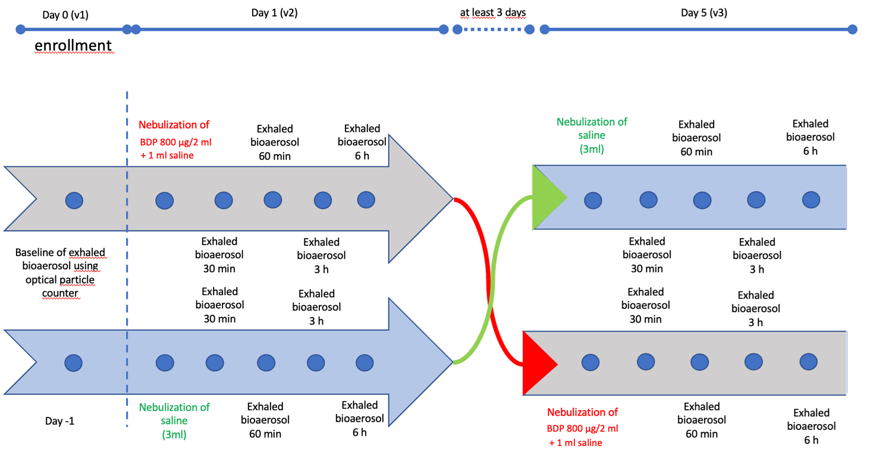
Efficacy variables | Exhaled bioaerosol particles characterised as mass and size.
Safety variables | Not applicable
Sample size calculation | As a pilot study, a formal assessment of study power is not required. However, we estimate that about 15-20 patients will be sufficient to obtain the data.

